Creating a Opswat connection for SpecterX Gateway

Prerequisites
An operative on-prem SpecterX Gateway

Objective

Integrate the tenant's own OPSWAT MetaDefender instance with the SpecterX file-upload pipeline so that every file routed through the platform is scanned and enforced by the organization's security policy.

Tasks
Obtain the container image – Get the correct opswat-onprem-service image for the tenant from the SpecterX DevOps team and place it on the Linux LAN host

Update the /opt/specterx/docker-compose.yml file on the LAN host:
opswat-onprem-service-<tenant>:
container_name: opswat-onprem-service-<tenant>
image: "075493908512.dkr.ecr.eu-central-1.amazonaws.com/opswat-onprem-service:<tenant>"
restart: always
environment:
- STAGE=staging
- INTERVAL=5
- USUAL_TIME_TO_SCAN=5
- STORAGE_PATH=/mnt/files_storage
- API_URL=https://<tenant>-api.specterx.com
- API_KEY=<SPECTERX_BECKEND_KEY>
- INTRANET_BASE_API_PATH=https://spx-api.<tenant>.com
- SCAN_FLOW=folder
- SCANNER_TYPE=remote
- SCAN_MAX_WORKERS=10
- SCAN_QUEUE_URL=https://sqs.eu-central-1.amazonaws.com/075493908512/opswat-onprem-queue-<tenant>
- META_DEFENDER_URL=https://api.metadefender.com/v4
- META_DEFENDER_RULE=sanitize
- META_DEFENDER_API_KEY=dbb6e62920ea1d9155d5231b4365d2ea
- META_DEFENDER_WORKFLOW=SpecterX
- SENTRY_DSN=https://6d92c08e0da478a820477eb0f643ca28@sentry.specterx.com/4508019499794432
volumes:
- /media/storage:/mnt/files_storage:rw,shared

Set the storage-connector flag – Ensure the OPSWAT_ONPREM_FILE_SCAN=true flag is set in the storage-connector-service container environment for the tenant.

Verify SpecterX backend configuration – Double-check that the SpecterX backend configuration for the tenant is set correctly to enable OPSWAT scanning and proper file flow.

Sanity checks
- docker logs shows "Running onprem MetaDefender file scanning process" on startup.
- Upload a small sample file ➜ appears in scan/ then in the final folder within 1 min.
- Upload EICAR test file ➜ file disappears and a blocked e-mail is triggered.
- OPSWAT dashboard shows the two scans with allowed / blocked verdicts.

Definition of done
All uploaded files in the web platform are scanned via the organization's OPSWAT instance.
files are stored and accessible; malicious or errored files are prevented from upload and the user is notified.

Troubleshooting

- Nothing moves from scan/ – container not running or missing NAS write permissions.
- Callback 403 in logs – API_KEY or API_URL mismatch ➜ re-check secrets.
- ScanTimeoutError – MetaDefender queue overloaded, raise USUAL_TIME_TO_SCAN or investigate OPSWAT load.
- Allowed file marked blocked – confirm correct META_DEFENDER_RULE or update tenant workflow.
- Container restarts repeatedly – look for Python stack-trace; missing env-var is the usual culprit.

How does it work?

- A user uploads a file; the binary lands in SpecterX temporary cloud storage.
- An entry is pushed to the Event Queue describing the file (ID, name, staging path).
- The Scan Coordinator Service consumes that entry (deployed on customer chosen infrastructure)
- The service downloads the bytes in-memory and hands them to the MetaDefender scan engine.
- The service waits (polling) until a verdict is produced.
- Handles verict: • If the verdict is allowed ➜ the file is copied / moved to on-prem permanent storage.
• If the verdict is blocked or an error occurs ➜ the file is discarded from the staging folder.
- The outcome is reported to the SpecterX notification API: • If the verdict was allowed ➜ notify the recipient of the recieved file. • If the verdict is blocked ➜ notify the sender of the blocked verdict.
The architecture enforces a strict contract:
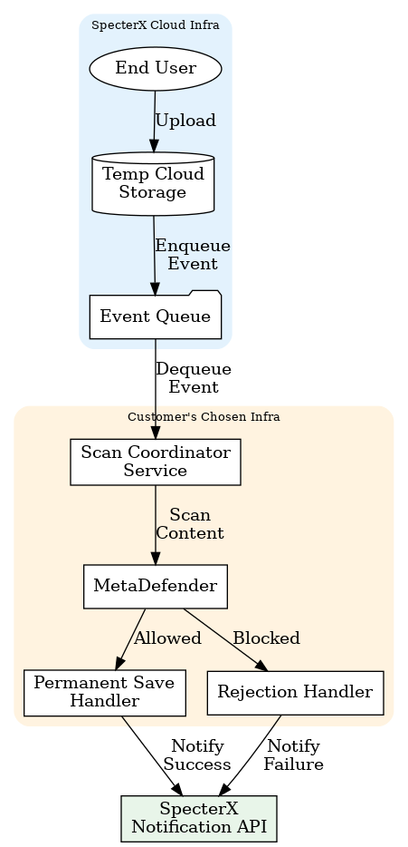
• Only files with an allowed verdict are committed to the permanent storage.
• Un-scanned, malicious or errored files are never written to disk (and, for folder-based staging, any temporary copy is erased).

